User Administration and Permission

AAA--- Authentication, Authorization and Audit
Authentication: you have an access of login into the server like you have username and passwd details . if yes then your authenticated to the server.
Authorization: if you are login into server you are authenticated but you don’t have any access to execute any command or files or folder so you need to be authorize to access this.
Auditing: and then someone give you to authorization for executing command and files and folder. Then it will be monitor to in which time login and logout how much time user login in system. From where the user login. what command executed during login.

users | Super user | System user | Normal user
Name | Root | Any system user like apache,nginx. | Any user that are create by super user
Shell | Bash | Nologin | Bash
UID | 0 | 1-999 | 1000-60000(expandiable)

Group and types of Group:
Group is the collection of users.
User have a single primary group and multiple supplementary (secondary).
primary group: when we created any user then automatically create the one group same name like user.
Supplementary group: when we created group and add user to this group this is a supplementary group.
Su rhel & su – rhel
su – rhel = get’s the fresh login to the shell and show /home/rhel as default directory and .
su rhel = it does not get the fresh login shell it just change the user identity uses the root shell and default directory is /root shows
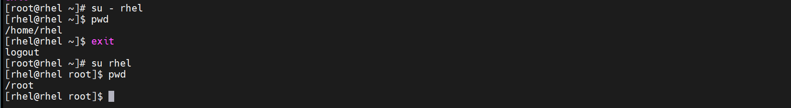

- Useradd
- passwd
- Groupadd
- Gpasswd - We set a password for a group to allow non-members to temporarily join the group using the newgrp command
ex- we have admin group and it have access to specific directory and we need to access this but we don’t have access and we need this for the temporary everyday. So we set passwd to group and add temporary add the user to this group using newgrp command. for temporary access the file
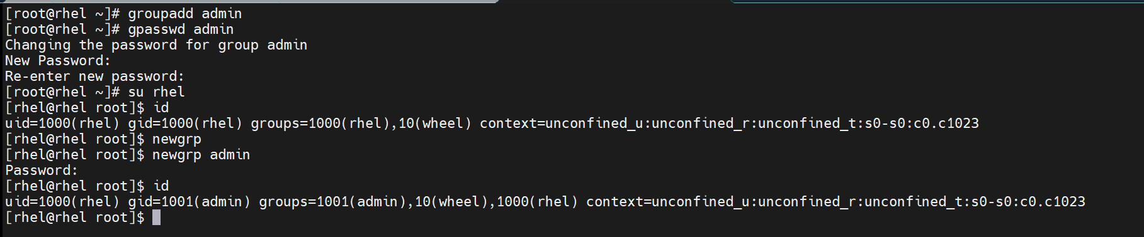
- /etc/passwd
- /etc/group
- Userdel <user-name> - this is just delete the user not userdata
- Userdel -r <user-name> - delete the user as well user data
User database files:
User info - /etc/passwd- contain 7 colon separated fields
Ex- rhel:x:1000:1000:rhel:/home/rhel:/bin/bash

User password info and age - /etc/shadow- contain 9 colon separated fields
Ex rhel:$6$dru5vovAPEgZHi3h$QgyQVUcrRX8EaoOkxoKMreCExyhn3hWYYTR6pzfCkdmcx8G0GTM.tt74K69PHlX8vV2w/L4PgWSpUFJNCeAKa/:20357:0:99999:7:::
- Usename
- Passwd
- Last time passwd change
- Min days passwd can change limit
- Max day passwd can change limit
- Warn before passwd expire
- Inactivity periods
- Account expiry
- Blank for future used
Group info - /etc/group - contain 4 colon separated fields
Ex - admin:x:1001:rhel
- Groupname
- Passwd pointer
- Groupid
- Username present group

Group password info - /etc/gshadow – contain 4 colon separed fileds
Ex- admin:$6$yIBKCrtYRUa/sJw1$y/B6GYtitTiNICasTAKtKy8qSlcvsKJg6gpdfD8ui6pXeEmqcdkhldL3.Ipi3H1d3D8Ly2RuSm7TPUYmt1EC9.::rhel
- Groupname
- Grouppasswd
- Group administrator name
- Username present in group

When we run useradd karan then in backend this file created.
/etc/passwd
/etc/shadow
/etc/group
/etc/gpasswd
Home directory created
/home/karan
Create file for mail
/var/spool/mail/karan
Copy skeleton from /etc/skel/ to home directory.
Advanced command:
- Usermod - changing the user modification
- Change the user ID
usermod -u <new-user-ID> <username>
ex- usermod -u 1001 karan
- Change the comment section or add description
usermod -c <comment-section> <username>
ex- usermod -c this is practice comment karan

- Change the shell of user
usermod -s <shell name> <username>
Usermod -s /sbin/nologin karan

- Change the primary group of user
usermod -g <groupname> <username>

- Want to add user into another supplementary groups
usermod -G <groupname> <username>

- Want to add multiple supplementary groups to user
usermod -aG <groupname> <username>

- Change the name of user
usermod -l <new-usernamer> <old username>

- Change the HOME directory
usermod -d /home/karan -m <username>

Wheel: when we add any user in wheel group it automatically get super user permission.
1. Usermod -aG wheel karan
Gpasswd:
want to remove user from group
gpasswd -d <groupname> <username>
chage: change the passwd policies of user.
give the details of user passwd policies.
chage -l <username>
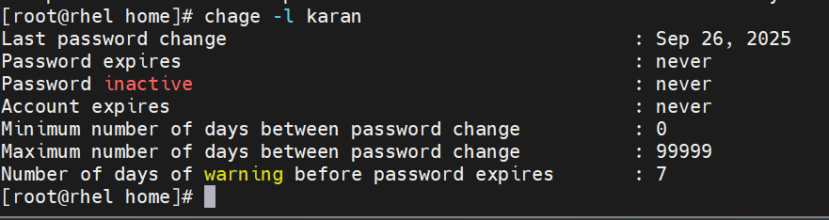
want to change policies
chage <username>
w : currently how many user login in system.
last : last user login history which user login and which user logout.
it fetch data from /var/log/wtmp file.
lastb: last user login history for failed login .
it fetch data from /var/log/btmp file.
user default configuration:- means whenever I create user using useradd command it directly create home directory in /home get userid more then 999+ so why this is cause of default configuration files.
/etc/default/useradd
/etc/login.defs
in this file it defines the default configuration for new user created like umask, mail path home directory path defined all kind of information
/etc/security/limits.conf
in this file it defines
1. How many user can login my system max 3 or 4 like this
2. The user in my system how much size of file created
3. Max number of process
4. Such type of limits we can done on user by defining values in this files.
Permission
 | Read | Write | execute
Files | Open, read files | Modification | execution
directory | Dir content listed,but can’t move inside dire | Content inside dire can create/delete/modify | Have access to content means only move inside directory

drwxr-xrw-. 2 root root 18 Sep 29 06:03 dada
owner – group – other ownername groupname size time-stamp file or dire name
change the owner permission
chmod o=rwx <file or dire name>
change the group permission
chmod g=rwx <file or dire name>
change the other permission
chmod o=rwx <file or dire name>
change the owner of file or dire
chown <owner name> <file name>
change the group of file or dire
chgrp <group name> <file name>
umask: when we create file or dire it get automatically permission this is due to umask. When we not set umaks then by default permission of file is 666 and dire is 777 but it’s not secure so we used umaks for setting the file and dire permission.
umask is 0022
then file permission should be = 644
and dire permission should be = 755
umask 0022 – command to set umask but this is not permanent when we need to make it change file present in home directory.
Vim ~/.bashrc
add value umask 0022
To change umask for all user’s in linux system. Change this file
/etc/profiles
add value at the end umask 0033
ACL:
when we need give specific permission to specific user use this
1. Setfacl -m u:username:permission file or directory
ex. setfacl -m u:karan:rwx /test/test.txt
2. Setfacl -m g:groupname:permission file or directory
ex. setfacl m g:karangroup:rwx /test
when we set the acl on whole files and dire within test folder use this.
ex. setfacl -R -m u:karan:rwx /test/
remove acl from file or directory
setfacl -x u:username file or directory
remove all acl from file or directory
setfacl -b filename
special permission:
1) SUID
apply on owner and executable file
when SUID apply on owner then any other user executed this file should be run by the owner
ex: -rwsr-xr-x. 1 root root 32648 Aug 10 2021 /usr/bin/passwd
In this example s it does’nt have any extra field it place over the x if this ‘s’ is small then it have executable or ‘x’ is available if the ‘S’ then this file is not executable.
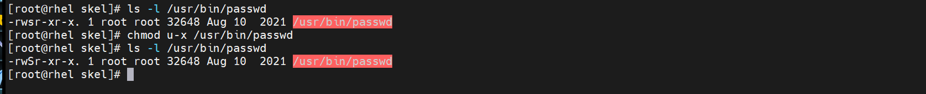
in this SUID apply on owner when other user run this command should be run by the root .
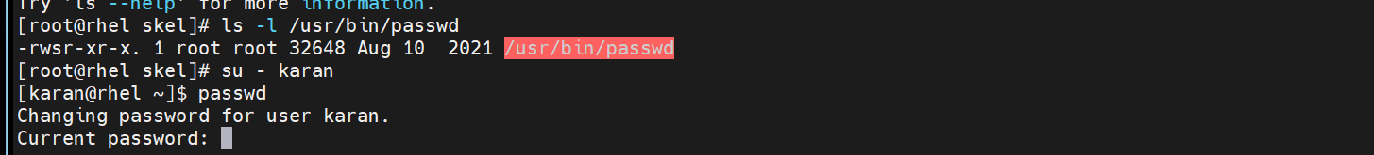
Run passwd command by the karan user but this executed by the root user

- SGID
SGID is apply on group owner + directory
before SGID apply when directory (contain group owner is root) have full access to other users . any user create files into this then this files group name should be be user primary group name.
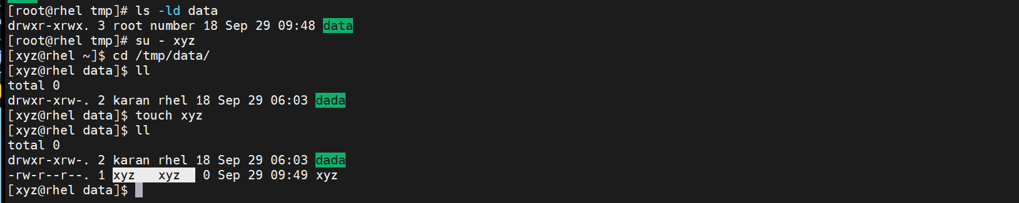
This is in normal when we apply SGID on this directory then all files created under this dire by any user their group owner should be root .
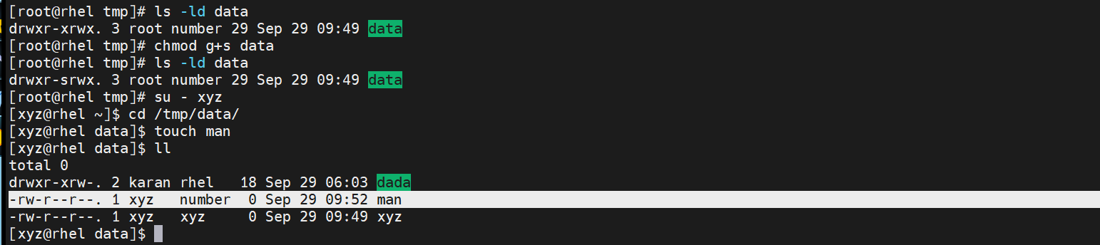
Useful:
Like in apache server all files in /var/www/html with group name apache. While developer make change in this files continuously then this file group owner changes. Then apache is not working. To solve this this apply SGID to /var/www/html then all files created in this directory have apache group owner.
- Stikey bit
it is apply on other user + Directory
when we apply stikey bit on directory then any user create the file inside this directory only those can deleted or modified not other user deleted this or modified this even have full permission to this file.
chmod o+t directory
It is also applied on files.

Attribute:
lsattr filename
apply the attribute
chattr +i filename
when we apply the attribute then this file can not be change or deleted if we try to delete this from root user also.
It will be deleted or modified by removing the attribute
chatter -i filename

SUDO : (super user do)
Vim /et c/sudoers - in this file there is entry like this
root ALL=(ALL) ALL
root = username
ALL= this username is login from any where run the sudo command
(ALL) = run as
ALL = this contain command now it show ALL means all command have access
suppose we have user karan and we want to sudo give access on specific IP or localhost then this user can’t run sudo command from another laptop
karan 192.168.1.28:(ALL) ALL
suppose we need to access to sudo user on a specific sudo command use this
like useradd , move to directort /root and passwd command use this
firstly get the path of the executable file
useradd = /usr/sbin/useradd
passwd= /usr/sbin/passwd
karan ALL=(ALL) /usr/sbin/useradd,/usr/sbin/passwd,/root
we want to run all sudo command except some specific command use this format
like karan user have all sudo access expect rebbot the system
karan ALL=(ALL) ALL,! /usr/sbin/reboot
When we want to give sudo permission to group .
add the same line like user like this just add % at starting
%groupname ALL=(ALL) ALL

Note- edit the /etc/sudoers file is not a standard procedure so just create file inside /etc/sudoers.d directory and give entry
Vim /etc/sudoers.d/karan
and add this line
karan ALL=(ALL) ALL

